Supplementary Materials – Population Projection

- Statistical Bias Corrections

We applied two statistical bias correction methods to raw, daily GCM output. For temperature forecasts (both the daily mean and the daily minimum), we applied additive linear scaling as described in Hempel et al. (2013). For precipitation forecasts (total daily), we applied local intensity scaling as described in Smitha et al. (2018). Both methods were chosen to correct specific systematic biases (i.e. deviance from an expected average) identified when we compared historical GCM output to real climatic measurements taken from Algonquin East Gate Climate Station’s historical records over a 20-year period (from 2005 to 2024). Further, both methods assume stationarity of bias: the idea that systematic bias in the past will manifest itself in the same way in the future. Finally, both methods fit correction coefficients to historical data from the SSP 3 climate scenario specifically, which are applied to all three scenarios (correction coefficients fit using other scenarios were very similar, since the three scenarios differed little from 2005 to 2024).

  - Temperature Bias Correction Procedure

For both mean and minimum daily temperature, simulated data showed similar trends to observed data over time, but with consistently higher averages (Figure 1). Simulated temperatures also exhibited smaller day-to-day variance compared to observed trends, likely because we used ensemble means, which artificially deflates the variance. Methods that correct the variance and the mean in simulated temperature data simultaneously exist, but have been shown to impact the climate change signal in certain datasets (Hagemann et al., 2011). Given how temperature projections are used in our main analysis, we opted to only correct the systematic bias in the average, preserving the climate change signal most faithfully. The method used, additive linear scaling, is described below.

Let $i$ represent the March of a given year between 2005 and 2024. Then, let $T_{ij}^{\text{OBS}}$ represent the observed temperature (mean or minimum) of the $j^{\text{th}}$ day in that month respectively. $T_{ij}^{\text{SIM}}$ and $T_{ij}^{\text{ADJ}}$ are defined similarly, for simulated (SIM) and bias-corrected (ADJ) daily values. We calculate the linear scaling constant $C$ as follows:

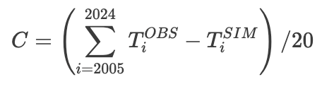 | Eq.1.1

where $T_{i}^{\text{OBS}}$ and $T_{i}^{\text{SIM}}$ represent the average temperature of the $i^{\text{th}}$ March from 2005 to 2024, for observed and simulated data respectively. $C$ can then be used to additively scale daily simulated temperatures like so:
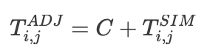 | Eq.1.2

Notice that $C$ is calculated over the entire period, and not per-year. This allows us to apply the correction shown in Equation 1.2 to every March in the forecasted simulated data. This procedure can then be repeated for April and May, mean and minimum temperatures separately, resulting in the estimation of 6 linear scaling constants to correct GCM-derived temperature forecasts.

  - Precipitation Bias Correction Procedure

For daily total precipitation, simulated data had similar monthly and seasonal averages as observed data, but grossly underestimated the day-to-day variance in precipitation, effectively predicting a drizzle each day. This resulted in an underestimated number of rainy days, and an underestimated intensity of wet days. Since the precipitation main effect used in our analysis is sensitive to the number of rainy days (see main text), this drizzle bias required correction. The method used, local intensity scaling, is described below.

Let $i$ represent the March of a given year between 2005 and 2024. Then, let $P_{ij}^{\text{OBS}}$ represent the observed precipitation (total) on the $j^{\text{th}}$ day in that month respectively. $P_{ij}^{\text{SIM}}$ and $P_{ij}^{\text{ADJ}}$ are defined similarly, for simulated (SIM) and bias-corrected (ADJ) daily values. First, a fixed threshold $t$ is determined such that the average number of wet days with simulated precipitation totals below $t$ is equal to the average number of observed dry days. This constant is used to correct for the number of dry days in the simulated data. Then, we calculate the observed average precipitation among wet days ($D_{1}$), and the average precipitation among simulated days above $t$ ($D_{2}$). Their ratio, $D=\frac{D_{1}}{D_{2}}$ , is used to correct for the expected intensity of wet days in the simulated data. These constants are then applied to the simulated precipitation data as follows:
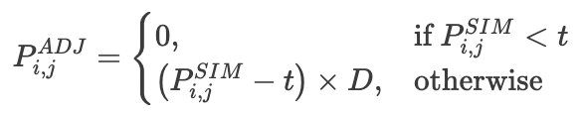 | Eq.1.3

Similarly to temperature, 3 sets of ($D,t$) pairs were fit, for each month in our dataset.

  - Bias Correction Results & Diagnostics

All fitted correction factors are shown in Table 1. Monthly biases in simulated temperatures were more extreme earlier in the season, and for minimum temperatures. Simulated precipitation days were deemed dry when their total precipitation did not exceed around 2mm, representing a light shower. Simulated wet days saw their total precipitation amount inflated by a factor of 4 to 7, more intense later in the season. Figures 1.1, 2.1, and 3.1 illustrate the effect of the correction procedures compared to observed data, for each climate variable.
Correction Factor | Value
March mean temperature offset (ºC) | -1.5483353
April mean temperature offset (ºC) | -1.3805482
May mean temperature offset (ºC) | -0.5843397
March minimum temperature offset (ºC) | -2.916618
April minimum temperature offset (ºC) | -1.903555
May minimum temperature offset (ºC) | -1.668913
March dry day threshold (mm) | 2.099063
April dry day threshold (mm) | 2.156163
May dry day threshold (mm) | 2.567102
March intensity coefficient (unitless) | 4.07696
April intensity coefficient (unitless) | 5.930714
May intensity coefficient (unitless) | 6.853495
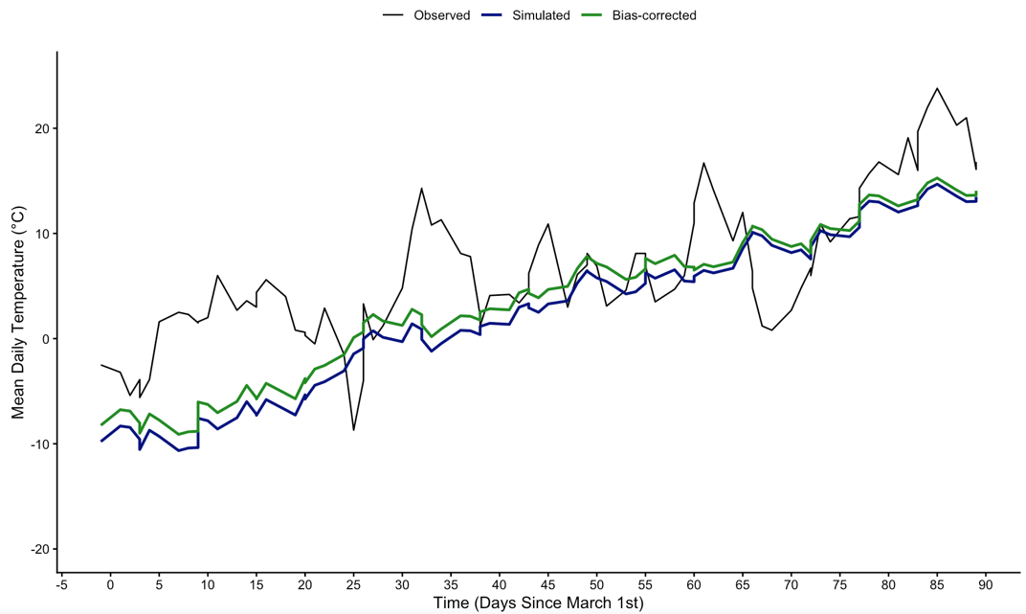
Figure 1.1: Time series of observed (black), simulated (blue), and bias-adjusted (green) mean daily temperatures during the spring of 2010. Simulated data is taken from SSP scenario 3. Correction behaviour and overall trend were similar for all years between 2005 and 2024, and across the three scenarios we considered.

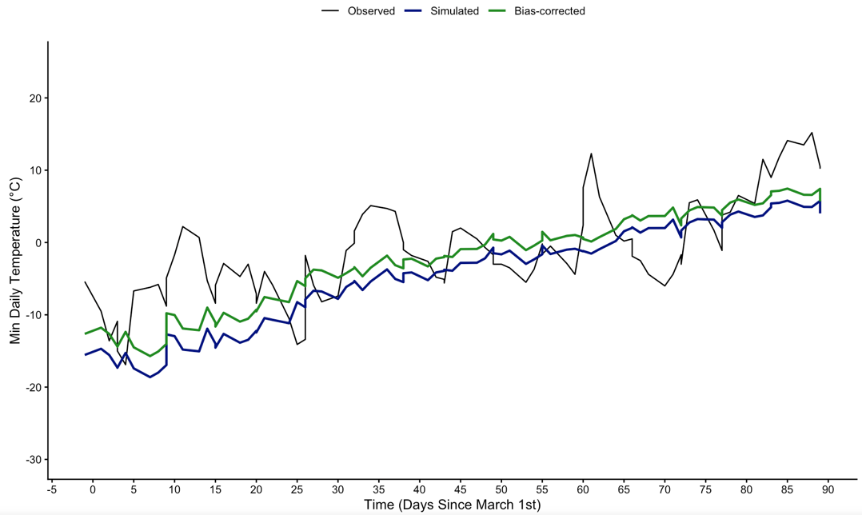
Figure 1.2: Time series of observed (black), simulated (blue), and bias-adjusted (green) minimum daily temperatures during the spring of 2010. Simulated data is taken from SSP scenario 3. Correction behaviour and overall trend were similar for all years between 2005 and 2024, and across the three scenarios we considered.

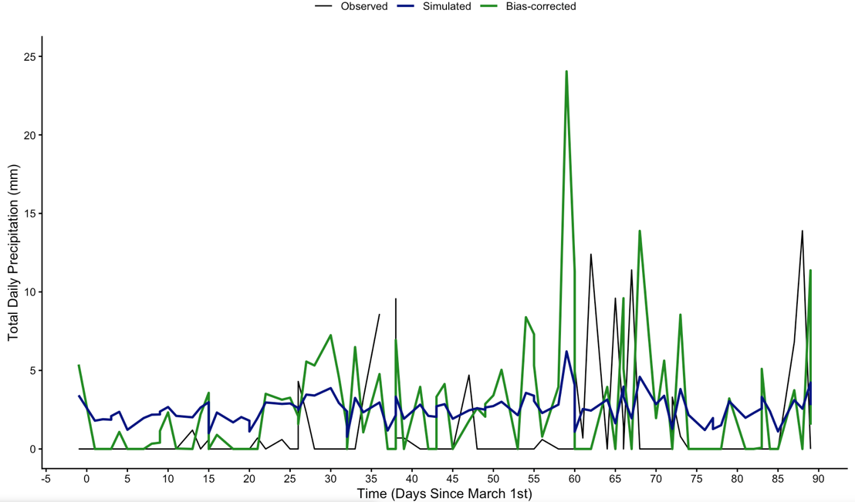
Figure 1.3: Time series of observed (black), simulated (blue), and bias-adjusted (green) daily precipitation totals during the spring of 2010. Simulated data is taken from SSP scenario 3. Correction behaviour and overall trend were similar for all years between 2005 and 2024, and across the three scenarios we considered.

- Visually Validating Environmental Index Forecasts

Bias-corrected climate variables were used to forecast the following annual variables:
- Breeding season start date (from which the breeding season end date was deterministically derived)
- Inbound temperature index (see definition in main text)
- Outbound precipitation index (see definition in main text)

Here we present our forecasted indices, for the period from 2008 (start of the BLISS project) to 2100 (end of available GCM estimates). Three forecasts were made in each case, one for each of the three climate scenarios considered. Shown concurrently are the observed indices, available during the BLISS project study period (2008 to 2022). These are shown in Figures 2.1, 2.2, and 2.3. In each case, the simulated projection is similar to the mean of the observed index during the BLISS study period. However, the true year-to-year variance in these indices was always larger than what was produced from the GCM data, apart from forecasted precipitation indices, which matched observed variance quite closely.

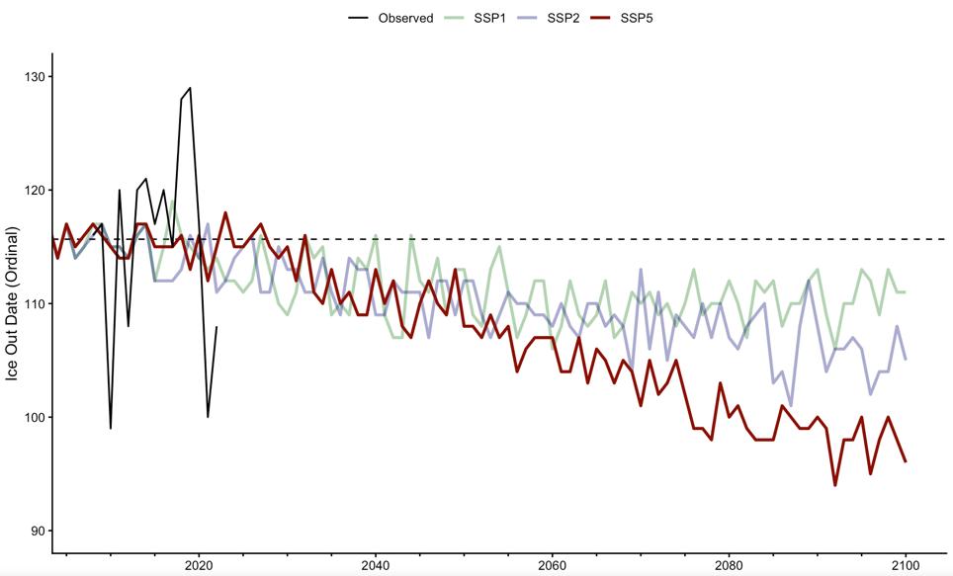
Figure 2.1: Time series of observed (black), and forecasted (colour) Bat Lake ice out dates, from 2008 through to 2024. Horizontal dashed black line indicates the average ice out date observed during the BLISS study period (2008 to 2024).

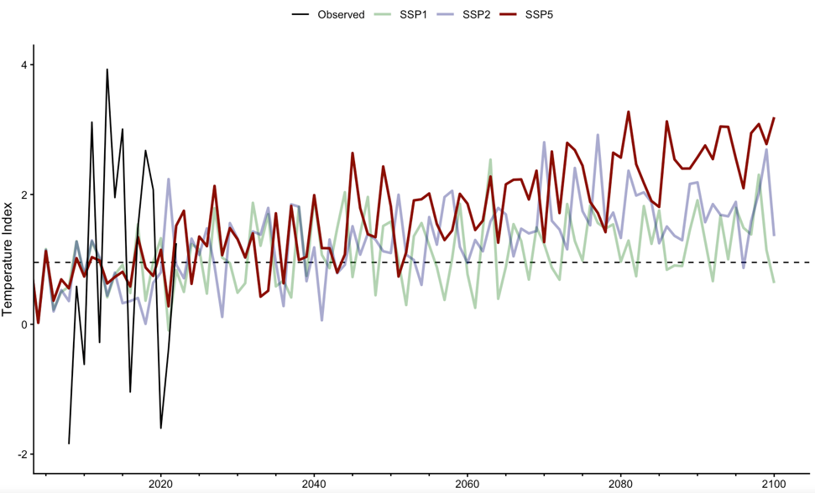
Figure 2.2: Time series of the observed (black), and forecasted (colour) annual temperature index, from 2008 through to 2024. Horizontal dashed black line indicates the average temperature index observed during the BLISS study period (2008 to 2024).

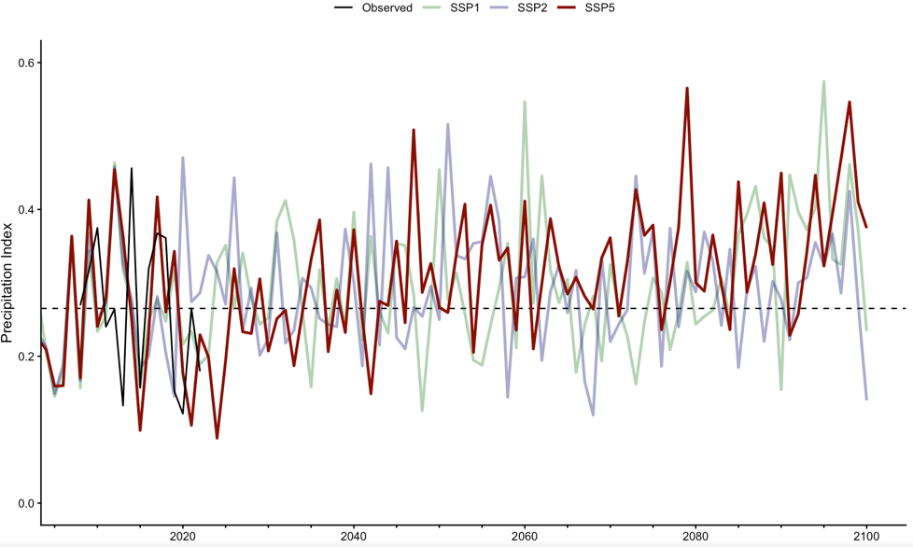
Figure 2.3: Time series of the observed (black), and forecasted (colour) annual precipitation index, from 2008 through to 2024. Horizontal dashed black line indicates the average precipitation index during the BLISS study period (2008 to 2024).

- Population Growth Model Specification

We used a modified age-structured population growth model to forecast the female Bat Lake spotted salamander population through time. Let $N_{t}$ be a vector of length seven representing the population of salamanders, binned into age groups, in year $t$. Then, the population in the following year ($N_{t+1}$) is calculated as follows:
$$N_{t+1}=N_{t}⋅L_{t}$$ | Eq 3.1

where $L$ is a population projection matrix, defined to be:
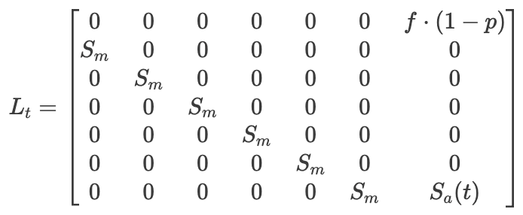 | Eq 3.2

Population growth in our model is governed primarily by the annual adult female survivorship term $S_{a}\left(t\right)$, which varies from year to year according to those environmental characteristics which correlated with survivorship in the CJS survivorship model fit in the main paper. We write:

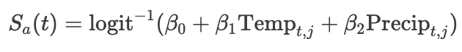 | Eq 3.3

where ${\text{Temp}}_{t,j}$ and ${\text{Precip}}_{t,j}$ are the standardized temperature and precipitation indices (see main text for full definitions) of Bat Lake in the year $t$ and climate scenario $j$. $β_{i}$ are the fitted coefficients from the CJS survivorship model. $S_{a}\left(t\right)$ estimates for every scenario for each year from 2000 to 2100 are shown visually in Figure 3.1.

Population growth also depends on three other life-history parameters which were held constant over time. $S_{m}$ denotes the subadult (i.e. metamorph) annual survivorship, which is shared between all subadult age classes, $p$ denotes the probability that a mature female skips reproduction in a year, and $f$ denotes the average number of offspring which survive until the next year produced by a reproducing female. Reproductive skipping is a well-documented component of yellow spotted salamander life-history. All parameter estimates are reported in Table 3.1. While skipping and fecundity estimates could be found in the literature, subadult survivorship could not. As such, the parameter was numerically optimized such that the resulting model had a finite rate of increase $λ$ near 1, when $S_{a}\left(t\right)=\text{logit}$⁻¹($β_{0}$) $≈$ 0.72 (i.e., adult female survivorship assuming study-average temperature and precipitation indices). We thought this decision sensible since the population did not show signs of increase or decrease during the BLISS study period (2008 to 2024). This baseline survivorship was also used to derive the stable-age distribution of the population, using the `eigen.analysis` function from the `popbio` package in R. Projections were initialized in the year 2019 at the base model’s stable age distribution with 1840 starting adult females.

Table 3.1: Symbols, definitions, and estimated values of each parameter in our projection model.
Parameter | Definition / Interpretation | Estimated Value
$$S_{m}$$ | Subadult (i.e. metamorph) survivorship. | 0.8551498
$$p$$ | Probability that a mature female skips reproduction in a year. | 0.5
$$f$$ | Average number of offspring which survive until the next year, produced by a reproducing female | 1.41
$$β_{0}$$ | CJS model intercept. | 0.9656941
$$β_{1}$$ | CJS model temperature index coefficient. | -0.762042
$$β_{2}$$ | CJS model precipitation index coefficient. | 0.4460179

We tested the robustness of our population projections by varying the following elements of our model and comparing the output with the base run:
- Different combinations of the non-focal parameters $p$, $f$ (optimizing $S_{m}$ such that $λ$ is near 1 in each case).
- Earlier starting year (checked from 2000 to 2025).

The results of these robustness tests are displayed in Figures 3.2 and Figure 3.3 respectively, and show that our projections are not sensitive to changes in either case. On top of these computational verifications, we know mathematically that varying the absolute starting abundance does not change the relative model dynamics at all.
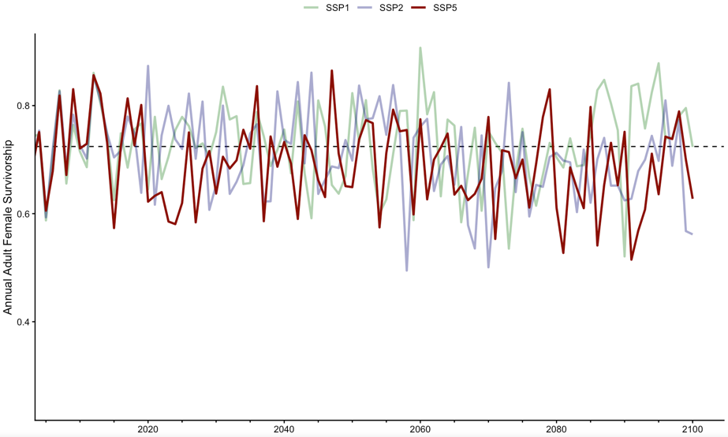
Figure 3.1: Time series of estimated adult female survivorship $S_{a}$ from 2000 to 2100, based on environmental data derived from global climate model projections. Three climate scenario considered. The horizontal dashed line indicates the adult female survivorship estimated at the average environmental values observed during the BLISS study period (2008 to 2024).

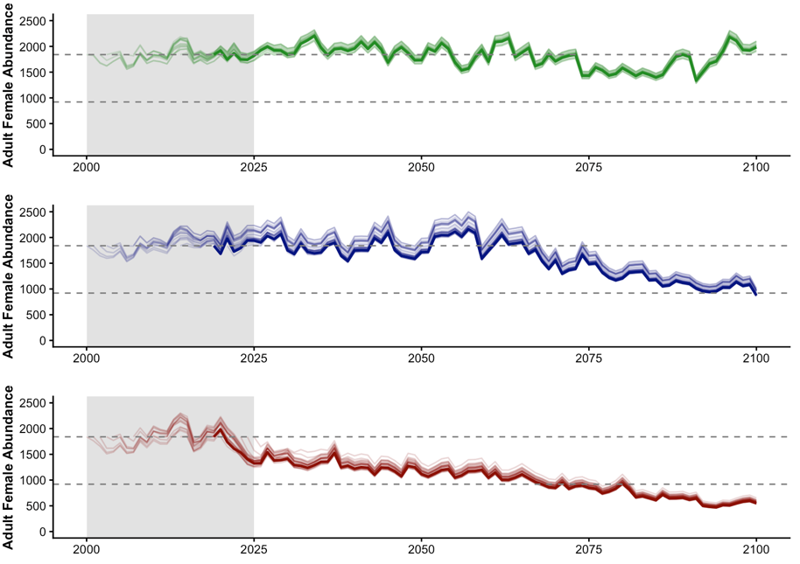
Figure 3.3: Population projections under the SSP1 (green), SSP2 (blue) and SSP5 (red) climate scenarios with variable initialization years. 2019 was chosen arbitrarily as a reference year, and projections initialized in 2019 are bolded in each case. Shaded grey region indicates the temporal range of initialization years considered (2000 to 2025). Upper dashed line indicates the projection’s starting abundance, and the lower dashed line denotes half the starting abundance.

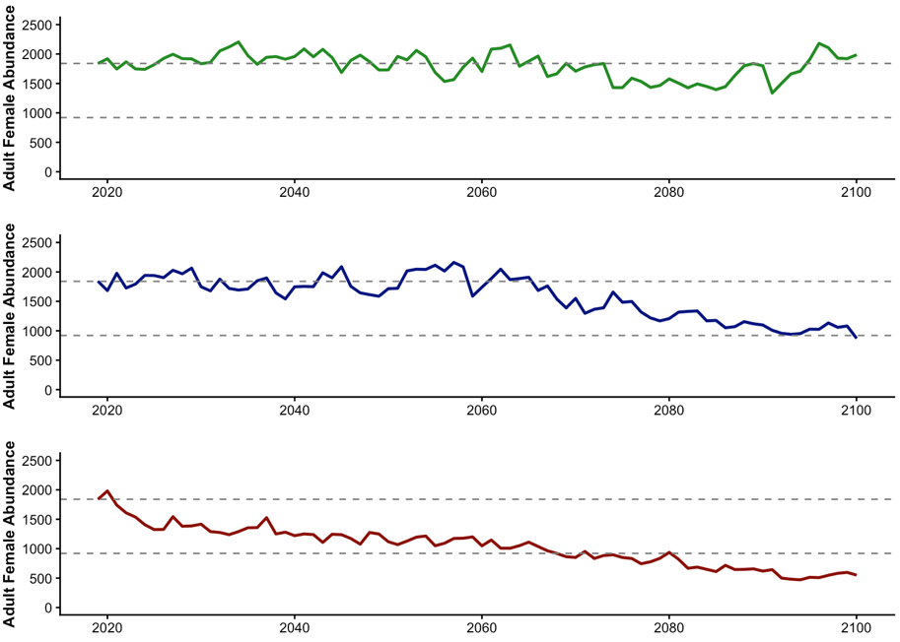
Figure 3.2: Population projections under the SSP1 (green), SSP2 (blue) and SSP5 (red) climate scenarios. Projections initialized at stable age distribution exhibited visually identical trends when $p$ and $f$ were varied systematically from 0 to 0.75, and from 1.1 to 2 respectively, such that $λ$ is held constant near 1. For each variant, the stable age distribution was recalculated and used to define the starting abundance. Upper dashed line indicates the projection’s starting abundance, and the lower dashed line denotes half the starting abundance.

Supplement For Results

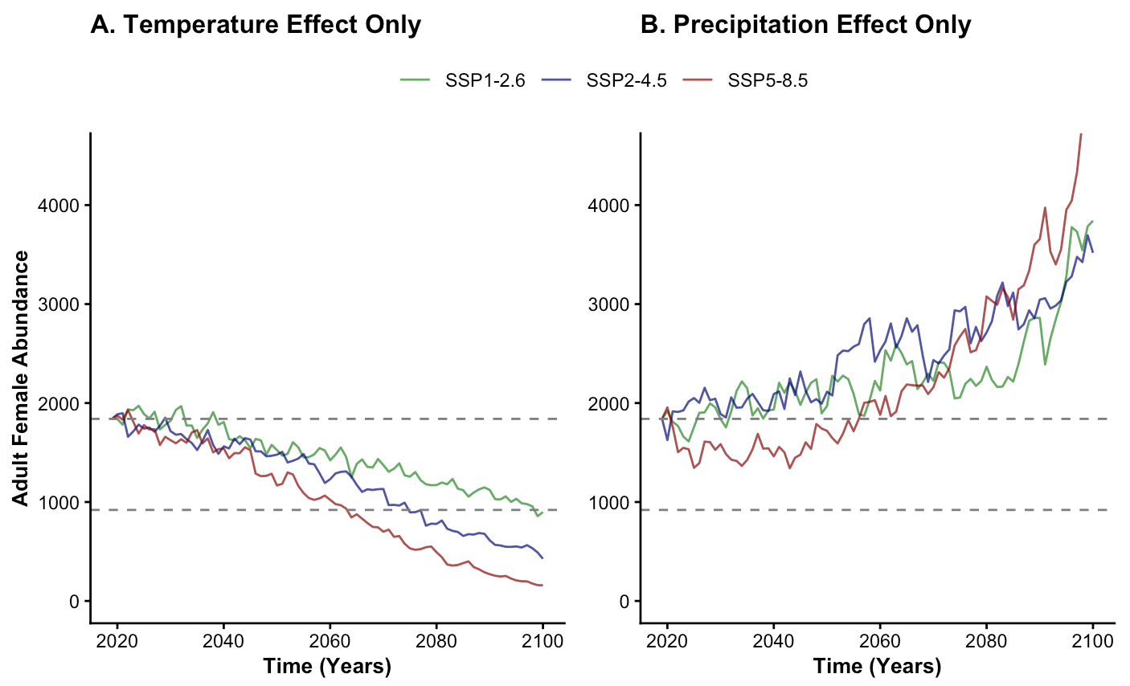
Figure X: Effect-suppressed forecasts of adult female abundance of the Bat Lake spotted salamander population, until 2100. Simulations are initialized at stabe age distribution, and in 2019. Red, green, and blue forecasts represent three future climate scenarios (SSP1, SSP2, and SSP5 respectively). (A) displays the forecast when only the effect of spring temperature is included, and (B) displays the forecast when only the effect of outbound precipitation is included. Upper and lower grey dashed lines indicate initial and 50% abundances respectively. We note that the population model used is density-independent. When density-dependent versions were considered, (A) was qualitatively similar same, while (B) increased only up until an arbitrarily-defined carrying capacity.

